Project Design Phase
Solution Architecture

Date | 27 February 2026
Team ID | LTVIP2026TMIDS41352
Project Name | ShopEZ:One-Stop Shop for Online Purchases
Maximum Marks | 4 Marks

Solution Architecture:
The solution architecture of ShopEZ bridges the gap between user shopping challenges and a scalable, secure technology solution. It defines how frontend, backend, database, and external services interact to deliver a seamless e-commerce experience.
ShopEZ follows a three-tier architecture consisting of:
- Presentation Layer
- Application Layer
- Data Layer
This structure ensures modularity, scalability, maintainability, and secure communication.

Example - Solution Architecture Diagram:
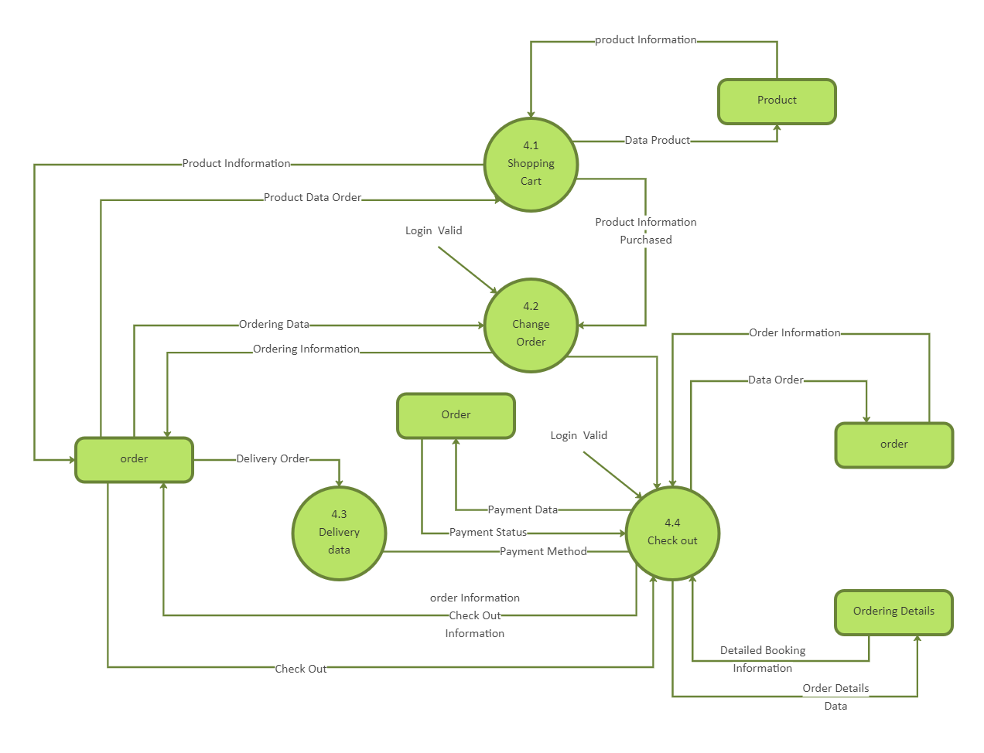
Figure 1: Architecture and data flow of the voice patient diary sample application
- Reference: AWS Industries Blog – Voice Applications in Clinical Research Powered by AI on AWS (Architecture and Design Considerations).
Available at: https://aws.amazon.com/blogs/industries/voice-applications-in-clinical-research-powered-by-ai-on-aws-part-1-architecture-and-design-considerations/
Referenced for architecture design considerations and example architecture diagrams.
- C4 Model for Software Architecture.
Available at: https://c4model.com/
Used to understand layered architectural diagrams and structured representation of system components.
- AWS Architecture Center.
Available at: https://aws.amazon.com/architecture
Used for best practices in cloud-based architecture design, including scalability and security.
- Medium – How to Draw Useful Technical Architecture Diagrams.
Available at: https://medium.com/the-internal-startup/how-to-draw-useful-technical-architecture-diagrams-2d20c9fda90d
Referenced for guidelines on creating simple and effective architecture visuals.
- MERN Stack Official Docs.
• React: https://react.dev/
• Node.js: https://nodejs.org/en/docs/
• Express: https://expressjs.com/
• MongoDB: https://www.mongodb.com/docs/
Referenced for component-specific implementation standards and architecture.
- JWT.io Documentation (JSON Web Tokens).
Available at: https://jwt.io/
Used as reference for secure authentication mechanisms in the proposed solution.
- MongoDB Atlas Documentation.
Available at: https://www.mongodb.com/cloud/atlas
Referenced for cloud database deployment guidelines and architectural considerations.

